a

Columbia Senior Center Brenda Kelliehan
Columbia United Methodist Church February 2025 Center Manager
510 Walnut Street Weekdays 7:30 am – 1:30 pm

Columbia, Pa. 17512 Phone: 717-684-4850

MONDAY TUESDAY WEDNESDAY THURSDAY FRIDAY
3.  8:00 Games/ Puzzles  9:30 Avoiding Trips & Falls -LRH  10:30 Geri-Fit | 4.  8:00 Games/ Puzzles  9:30 LCF- Valentine Painting  10:30 We Love Good News | 5.  8:00 Games/ Puzzles  9:30 Trivia - Who am I  10:30 Geri-Fit | 6.  8:30 Pinochle Club  9:00- Ponder This – Famous Quote  10:00 MHA – Dimensions of Wellness  Birthday Celebration | 7.  9:15 Full Body Strength Exercise – Yes2Next Video  10:00 Music – Alicia Mass
10.  8:00 Games/ Puzzles  9:30 CBC- BINGO  10:30 Geri Fit | 11.  8:00 Games/ Puzzles  9:00 ChatGPT  10:00- Jeopardy | 12.  8:00 Games/ Puzzles  9:30 Craft – Diamond Art  10:30 Geri-Fit | 13.  8:00 Games/ Puzzles  8:30 Pinochle Club  9:00 World Radio Day Activity  10:00 SPECIAL BINGO | 14.  8:00 Games/ Puzzles  9:00 President Day Activity  9:30 Skit- Be My Valentine  10:00 Music by The ValTones
17. CLOSED  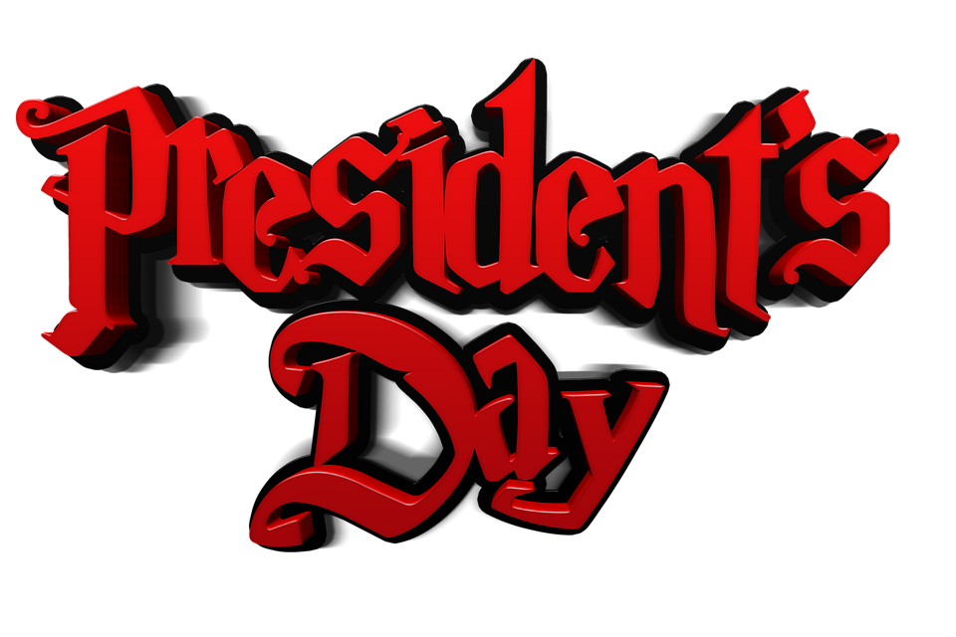 | 18.  8:00 Games/ Puzzles  9:00 Who is Susan B Anthony?  10:00 Chair Yoga w/ Teri C | 19  8:00 Games/ Puzzles  9:00- Trivia-Humana Medicare  10:30 -Geri Fit | 20.  8:00 Games/ Puzzles  8:30 Pinochle Club  10:00 Bandstand BINGO with Matt Cleveland | 21.  8:00 –Games/Puzzles  9:15 Full Body Strength Exercise – Yes2Next Video  10:00 -SPECIAL BINGO
24.  8:00 Games/ Puzzles  9:00 Getting To Know You Discussion  10:30- Geri-Fit | 25.  8:00 Games/ Puzzles  9:00 Who is Marian Anderson?  10:00 Trivia Bob Reigh | 26.  8:00 Games/ Puzzles  10:00 -Ways to Save on Utilities-  10:30 Geri-Fit | 27.  8:00 – Games/Puzzles  8:30- Pinochle  9:30 – Town Hall Meeting  10:00- Sara Ragusa Healthcare Premier - | 28.  8:00 Games/ Puzzles  9:15 Full Body Strength Exercise – Yes2Next Video  10:00 Nutrition – Jenn O
 |  | 

